**Open Source Graphics & Animation Tools**



**Gravity Space Rocket**

**Mid-Semester Phase 2**

**Submitted to**

**Dr. Durgansh Sharma**

**Professor, Cybernetics SCS, UPES**

**Submitted By**

Name: Avijeet Kumar

Roll No: 10

SAP ID: 500067577

B. Tech CSE (OSSOS) Department of Cybernetics

COMPUTER SCIENCE & ENGINEERING

**INDEX**

Contents

ABSTRACT INFORMATION: 3

PROCEDURE: 3

Step 1 - 3

Step 2 – 4

Step 3 - 5

Step 4 - 6

Final Outcome: - 6

# ABSTRACT INFORMATION:

Demonstrating the Gravity Movie Scene Rocket Launch.

# PROCEDURE:

## Step 1 -

1. **Take a default layout of blender.**

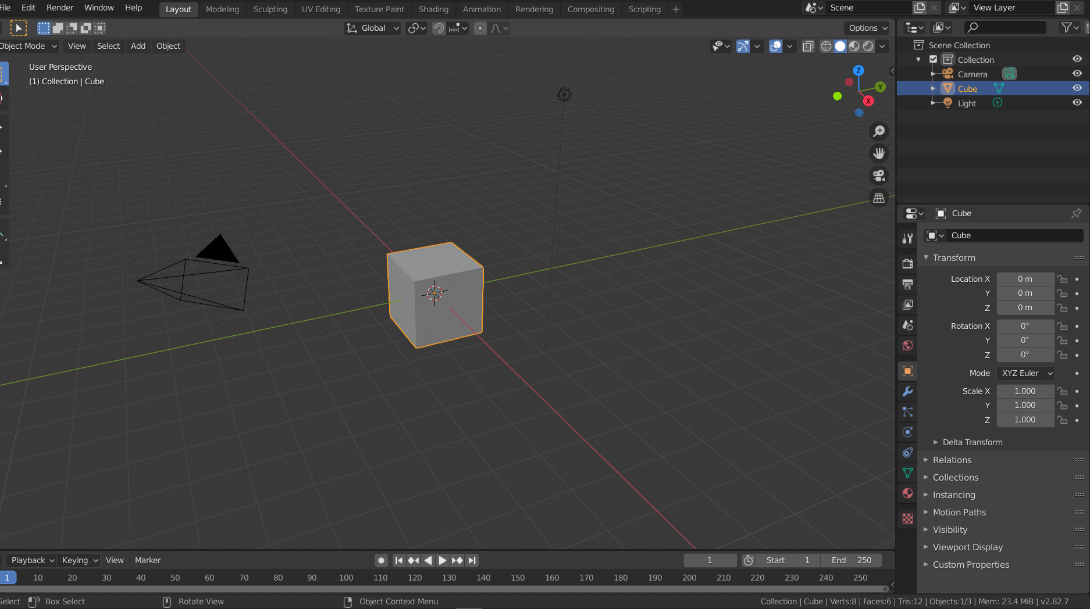

## Step 2 –

1. **Remove the default cube.**
2. **Select a cone from the mesh and place it at the centre.**

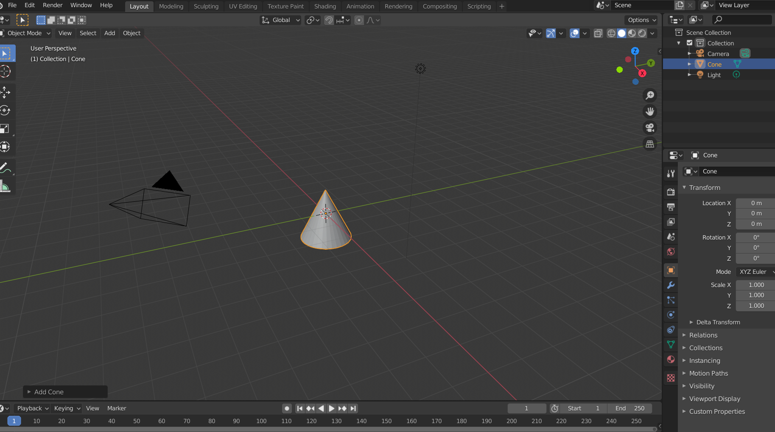

## Step 3 -

1. **Move the cone Vertically upwards as to make sufficient space for the body of the rocket.**
2. **Select the bottom of the cone.**

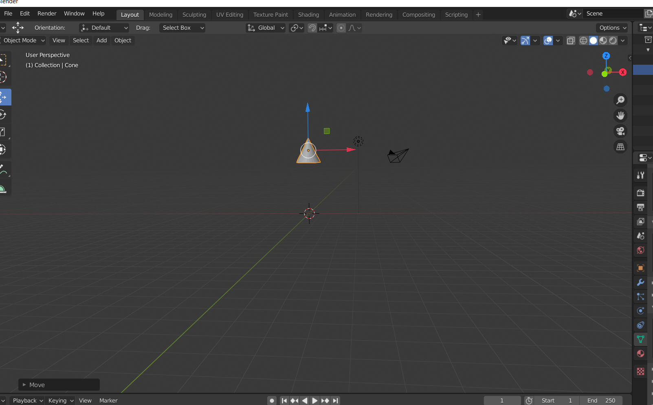

## Step 4 -

1. **After selecting the bottom of the cone and extrude the bottom to a specific length.**
2. **Do the previous step multiple times.**
3. **We can also adjust its spacing by pressing S after selecting the object.**
4. **We can adjust its details according to our requirements.**
5. **After this select the most bottom face of the rocket and add quick smoke to it.**
6. **Go to the physical properties of the quick smoke and select fire + smoke.**
7. **After the adjust the render setting for the animation according to your needs.**

# Final Outcome: -

